**FOP Lab Report1 Q3**

1. **Problem**

The question requires us to write a program that is able to calculate Cramer’s Rule with the formula: ax+by=e, cx+dy=f; x = (ed-bf)/(ad-bc) y=(af-ec)/(ad-bc) while the user inputs two input lines with the formula ax+by=e and cx+dy=f. When ad-bc=0 this particular program should print the line “The equation has no solution” and the program shall limit the range of input variables a,b,c,d to be between integers 1-9 only.

The first requirement of this program would be its ability to extract the coefficients a,b,c,d and equation value e,f from the input lines of user.

The second requirement is to let the original data type of input which is String to be converted into int in order to perform calculation.

The third requirement is to print out messages indicating false input or no solution for that equation.

1. **Solution**

To extract the coefficient in the input lines of user, we will need to use the method ‘String split()’ to perform this task. We indicate the parts where we want to separate from the input with the use of characters specified in a set []. Later, the separated elements will be stored in an array. Since we will need to separate a,b,c,d,e,f from ax+by=e, cx+dy=f, the set used to identify where to split will be [x+y=]. Resulting of this String split, we will have two String arrays( one from each input) with each 3 elements.

In order to perform calculation using the extracted String array elements, we will need to convert the data type of the array elements from String to int. To perform this, we will use the method ‘Integer.parseInt()’ to convert each elements of the arrays to int.

To check if the input of the user is applicable to the Cramer’s Rule formula, we will use ‘if’ to screen the input before performing the calculation. If the input is not applicable, an error message will be printed out to the user.

**Pseudocode:**

user input equation 1

read equation 1

initialise input 1 = “(equation 1)”

user input equation 2

read equation 2

initialise input 2= ”(equation 2)”

split input 1, input 2 to get coefficient of x, y and the equation value

parse String to int

declare variables to a,b,c,d,e,f

limit variables from 1-9

if ( int <1 || int>9) {

print“ The input is invalid”

}

if (ad-bc=0) print “The equation has no solutions”

else {

int x= (ed-bf)/(ad-bc);

int y= (af-ec)/(ad-bc);

}

**Flow Chart:**

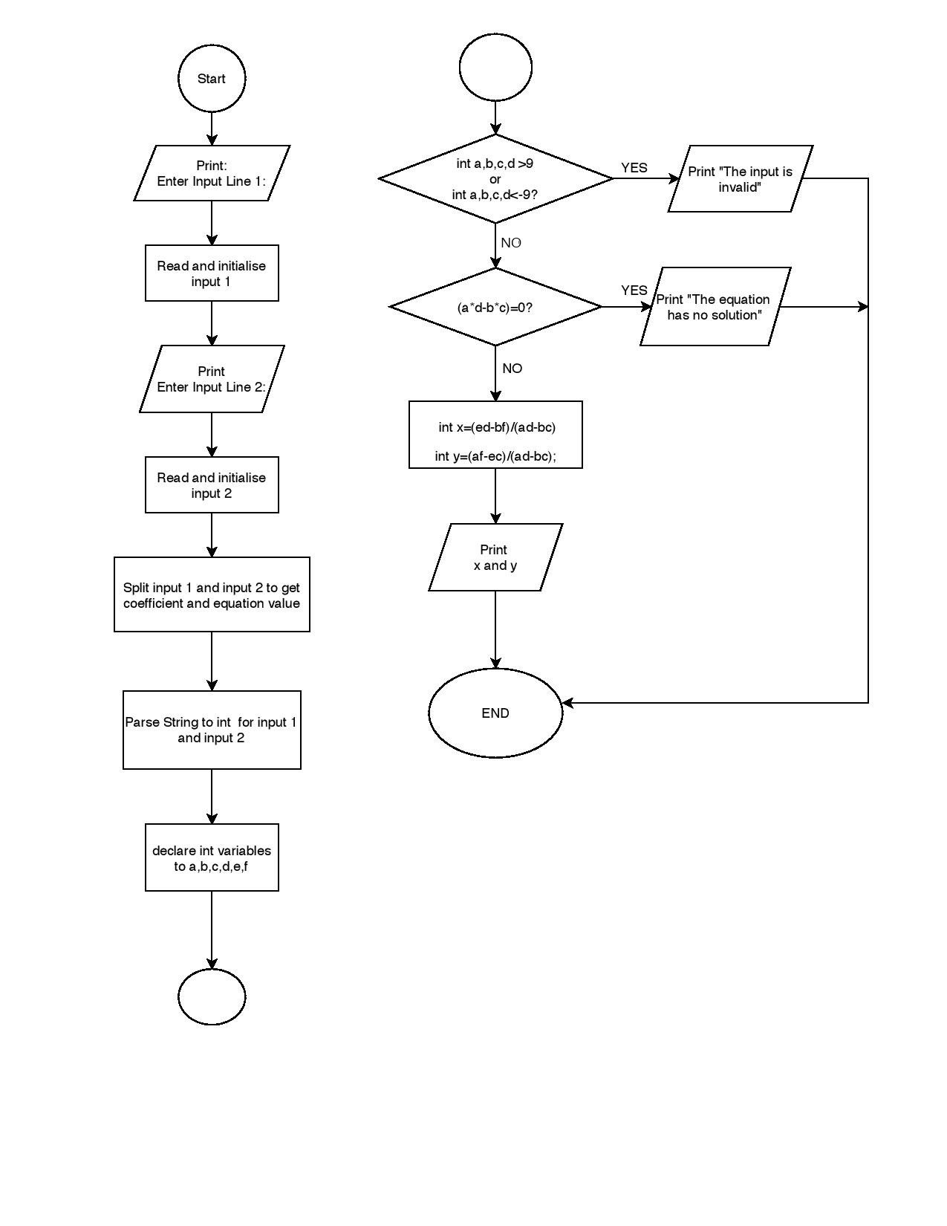

Start